8. Implement in Aggregation Function (e.g. sum, count, avg) on data base record run on mysql workbench

CREATE TABLE employees1 (
emp_id INT PRIMARY KEY AUTO_INCREMENT,
emp_name VARCHAR(50),
department VARCHAR(30),
salary DECIMAL(10,2)
);
Insert some sample data:
INSERT INTO employees1 (emp_name, department, salary) VALUES
('Pratiksha', 'IT', 40000),
('Trisharna', 'IT', 55000),
('Shravani', 'HR', 42000),
('Kunal', 'Finance', 40000),
('Akanksha', 'Finance', 35000),
('Aryan', 'HR', 28000);
select*from employees1;

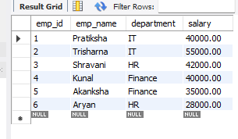

SUM () Total salary per department
SELECT department, SUM (salary) AS department_salary
FROM employees1
GROUP BY department;
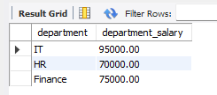
COUNT employees in each department
SELECT department, COUNT (*) AS total_employees
FROM employees1
GROUP BY department;

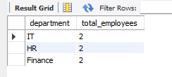
AVG () Average salary per department
SELECT department, AVG (salary) AS avg _salary
FROM employees1
GROUP BY department;

